Answer all the questions.

1. What is the output of the following C code?

|  |  |  |  |
| --- | --- | --- | --- |
| (a) | #include<stdio.h>  int main (void)  {  int n=9;  while(n<=50){  printf("%d ",n+3);  n+=3;  } return 0;  } | (b) | #include<stdio.h>  int main (void)  {  int sum = 0,item = 93;  do  {  item++;  sum += item;  if (sum > 100)  break;  }while (item < 97);  printf("Sum is %d\n",sum);  return 0;  } |

1. How many times the following code prints “PASUM”?

|  |  |  |  |
| --- | --- | --- | --- |
| (a) | #include<stdio.h>  int main (void)  {  int c = 0;  while (c < 10)  {  printf("PASUM ");  c++;  }  return 0;  } | (b) | #include<stdio.h>  int main (void)  {  int count = 0;  do  {  count++;  printf("PASUM ");  }while (count <= 10);  return 0;  } |

1. Write a C code for the following flowchart. Assume the user inputs an integer variable.

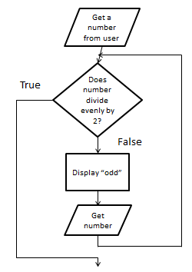

1. Write a complete C code to compute the sum of the cubes of the first n counting numbers, and store this value in total.   
   Thus if n equals 4, your code should put 1*1*1 + 2*2*2 + 3*3*3 + 4*4*4 into total.
2. Write a program that generates a table of conversions from Fahrenheit $(℉)$ to Celsius $(℃)$ for values from 0 $℉$ to 100 $℉$ in 5-degree increment. The conversion formula is: $$Celsius=5.0/9.0×(Fahrenheit-32)$$
3. Assume that there are 14,000 acres total with 2500 acres uncut, and that the reforestation rate is 0.02. Write a program that prints a table showing the number of acres forested at the end of each year, for a total of 20 years. The following is the sample output:  
     
    YEAR FORESTED ACRES AT END OF YEAR

----------------------------------------

0 2500.00

1 2550.00

2 2601.00

… …

19 3642.03

20 3714.87

1. Modify the solution to problem Q6 so that the user can enter the number of acres and the program will determine how many years are required for the number of acres to be completely reforested.

Hint:





1. Write a program to allow the user to set a new 4 digit PIN number and reconfirm it before being allowed to enter the menu at the Auto Teller Machine(ATM).(use do...while statement).

Eg output :

set your new 4 digit PIN :2468

Please reconfirm your new PIN :1234

Please reconfirm your new PIN :4321

Please reconfirm your new PIN :2468

congratulation,you have succesfully changed your PIN

Please select yout menu or exit

THANK YOU